ACSL
American Computer Science League
2006 - 2007

Contest #2

Intermediate Division

ACSL – The Next Generation
PROGRAM: Cellular Automata is a branch of mathematics that studies the effect of recursively applying a set of rules to the cells in a grid. This area of study was made famous by John Horton Conway’s publication in 1970 of the Game of Life. In this program the grid will be 7 x 7. The beginning state of each cell as described by Conway is alive or dead. In the grid below, live cells are shaded and dead cells are white. Neighbor cells are the at most 8 cells that surround a given cell. Once the rules are applied to all cells, a new grid is produced and is called the next generation. The rules are stated in terms of how many neighbor cells must be alive to create birth (changing a dead cell to a live cell) and survival (keeping a live cell alive). All other cells die or remain dead.
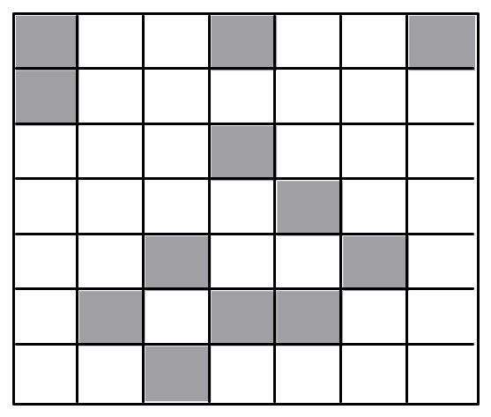

INPUT: There will be 7 lines of input. Line #1 will contain the number of live cells followed by their ordered pair locations. Line #2 will give how many rules there are for birth followed by how many neighbors must be alive for birth. This, using the same format, will be followed by integers giving the rules for survival. The next 5 lines will each contain 2 integers representing an ordered pair. Note (1,1) is located in the upper left hand corner. Sample line #2 indicates that birth occurs just one way – when exactly 3 neighbors of a dead cell are alive and that survival occurs two ways – when 2 or 3 neighbors of a live cell are alive. Line #3 indicates (5,2) is the target cell.

OUTPUT: For each of the last 5 lines of input, print the original status (A or D) of the target, how many live cells surround it and its state after one generation.

1. 12, 1,1,1,4,1,7,2,1,3,4,4,5,5,3,5,6,6,2,6,4,6,5,7,3
2. 1, 3, 2, 2, 3 1. D, 2, D
3. 5, 2 2. D, 0, D
4. 7, 7 3. A, 2, A
5. 5, 6 4. A, 0, D
6. 1, 4 5. A, 3, A
- 6,4

ACSL
American Computer Science League
2006 - 2007

Contest #2

Intermediate Division
ACSL – The Next Generation

TEST DATA

TEST INPUT TEST OUTPUT

1. 10,1, 4,1,7,2,1,4,1,4,3,4,5,5,3,5,6,6,2,6,5 1. D,1,A
2. 3,1,2,3,3,1,2,3 2. D,4,D
3. 2,4 3. A,2,A
4. 5,2 4. D,3,A
5. 5,3 5. D,1,A
6. 5,5
7. 7,1

